**Name: _____________________ Date: ______________**



**YEAR: 11**

**SUBJECT: ATAR HUMAN BIOLOGY UNITS 1 AND 2**

**TEST: Foetal Development, Diagnosis of Foetal Health, Birth, Post Pregnancy Changes and Lactation, Contraception methods and STIs.  
  
TIME: 60 minutes  
  
QUESTIONS: 20 Multiple Choice (20 marks)**

**6 Short Answers (32 marks)**

**1 Extended response (15 marks)**

**TOTAL MARKS: 67 marks**

**Part A MULTIPLE CHOICE SECTION [20 MARKS]**

**Questions 1-20**

1. A lack of folic acid in a pregnant woman’s diet can lead to
2. Abnormal bone growth
3. Still births and miscarriages
4. Neural tube defects
5. Abnormal cell growth
6. Which of the following genetic screening techniques allows for visual defects/abnormalities of the foetus to be determined?
7. Amniocentesis
8. Chorionic villus sampling
9. Maternal blood testing
10. Fetoscopy
11. Gamete Intrafallopian Transfer involves injecting what into the female’s reproductive system?
12. Eggs and sperm
13. Zygotes
14. Blastocysts
15. Donor sperm
16. The blastocyst is formed after the
17. Second day
18. Fifth day
19. Eighth day
20. Eighth week

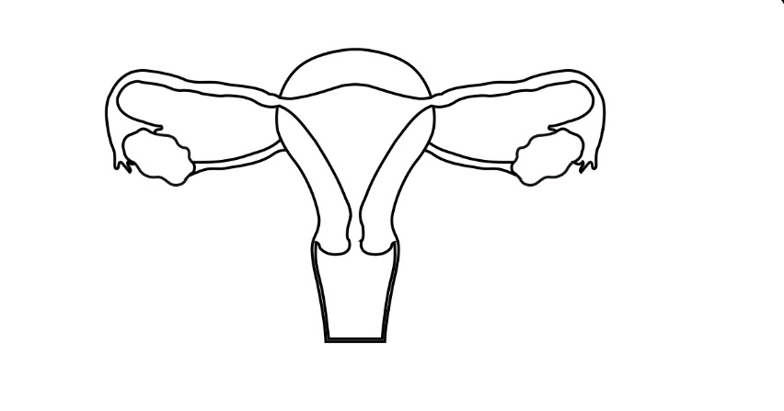

3

1. The optimum place of fertilisation is at point
2. 1
3. 2

1

2

1. 3
2. 4

4

1. The third stage of labour involves the expulsion of the
2. Foetus
3. Placenta
4. Placenta and membranes
5. Placenta, membranes and remains of the umbilical cord.
6. Which one of the following tissue pairs develops from the same germ layer in a developing embryo?
7. Bone tissue and the epithelium of the digestive tract
8. Muscle and lung tissue
9. Brain tissue and the epidermis of the skin
10. Liver and nerve tissue
11. During childbirth, there are a number of key events:
12. Dilation of the cervix
13. Crowning
14. Delivery of the placenta
15. Breaking of the waters
16. Contractions of the uterus
17. Secretion of oxytocin
18. Delivery of the baby

Using the above, the normal sequence of events is

1. vi, i, v, ii, iv, iii and vii
2. vi, v, i, iv, ii, vii and iii
3. i, ii, iv, vi, v, vii, and iii
4. vi, v, i, ii, iv, vii and iii
5. The placenta is the organ that allows for
6. Mixing of maternal and foetal blood.
7. Foetal blood gives off oxygen to maternal blood.
8. Maternal blood receives nutrients.
9. Foetal blood receives nutrients.
10. A woman who has heavy scaring to her uterus and has had several miscarriages in the last few years wants to have a baby. Which reproductive technology would be best suited to her?
11. Artificial insemination
12. Donor embryo
13. In-vitro fertilisation (IVF)
14. Surrogacy
15. Gonorrhoea and chlamydia are both sexually transmitted infections caused by:
16. Bacteria
17. Viruses
18. Fungi
19. Parasites
20. Which of the following methods of contraception operates largely by preventing implantation rather than preventing fertilisation?
21. Diaphragm
22. Intra-uterine device
23. The oral contraceptive pill
24. Condom
25. A test that can be done during pregnancy to check for foetal abnormalities such as Down’s syndrome and other chromosomal errors is:
26. An ultrasound
27. Chorionic Villus Sampling
28. Fetoscopy
29. Foetal monitoring
30. Which of the following is NOT a potential outcome for the foetus, if the mother is smoking whilst pregnant?
31. Increased growth rate
32. Increased risk of SIDS
33. Reduced birth weight
34. Increased chance of respiratory disease
35. The Ectoderm germ Layer gives rise to which of the following structures:
36. Entire nervous system
37. Lymphoid tissue
38. Cardiac muscle
39. Epithelium of lungs
40. Which two structures give rise to the foetal and maternal placenta respectively?
41. Amnion and endometrium
42. Chorion and endometrium
43. Amnion and chorionic villi
44. Chorion and chorionic villi
45. The transmission of sexually transmitted infections such as AIDS, syphilis and gonorrhoea can be limited by:
46. Oral contraceptive pill
47. Spermicide
48. Condoms
49. Intra-uterine devices
50. The hormone responsible for the milk letdown and uterine contractions during labour is:
51. Progesterone
52. Oestrogen
53. Oxytocin
54. Prolactin
55. The ductus venosus diverts foetal blood away from the:
56. Lungs
57. Liver
58. Placenta
59. Left ventricle
60. Which of the following is not a form of hormonal contraception?
61. Femidom
62. Mini pill
63. NuvaRing
64. Mirena IUD

**Year 11   
ATAR  
Human Biology**

**MULTIPLE CHOICE ANSWER SHEET**

For each question, shade the box to indicate your answer. Use only a blue or black pen to shade the boxes. If you make a mistake, place a cross through that square then shade your new answer. Do not erase or use correction fluid/tape. Marks will not be deducted for incorrect answers. No marks will be given if more than one answer is completed for any question.

|  |  |  |  |  |
| --- | --- | --- | --- | --- |
| **1** | a | b | c | d |
| **2** | a | b | c | d |
| **3** | a | b | c | d |
| **4** | a | b | c | d |
| **5** | a | b | c | d |
| **6** | a | b | c | d |
| **7** | a | b | c | d |
| **8** | a | b | c | d |
| **9** | a | b | c | d |
| **10** | a | b | c | d |
| **11** | a | b | c | d |
| **12** | a | b | c | d |
| **13** | a | b | c | d |
| **14** | a | b | c | d |
| **15** | a | b | c | d |
| **16** | a | b | c | d |
| **17** | a | b | c | d |
| **18** | a | b | c | d |
| **19** | a | b | c | d |
| **20** | a | b | c | d |

**PART B: SHORT ANSWER SECTION (32 marks)**

21. (a) Fill in the following table regarding the given contraceptive methods (4 marks)

|  |  |  |
| --- | --- | --- |
|  | Advantage | Disadvantage |
| Rhythm method | **No side effects**  **No cost**  **Religious acceptance** | **Time/effort**  **Not reliable**  **Requires long abstinence periods**  **Doesn’t protect against STI** |
| Vasectomy | **Permanent**  **Nearly 100% effective** | **Not easily reversed**  **Surgery**  **Doesn’t protect against STI** |

**One mark per category (4 total)**

(b) Is it possible for a man who has had a vasectomy to pass on the sexually transmitted infection HIV to his partner? Explain your answer. (2 marks)

**Yes, disease is transmitted via body fluids (1)**

**Although there is no sperm, semen is still transferred and so body fluids mixing (1)**

22. On the diagram of foetal circulation below, there are 2 structures labelled (a) and (b) that change at child birth.

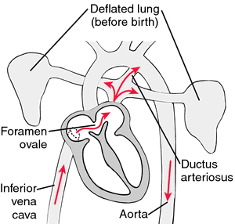

a.

b.

1. Name both of the structures in the space provided below (2 marks)
2. a = **foramen ovale (1)**
3. b = **ductus arteriosus (1)**

(b) There is a 3rd structure, not present in the diagram, that is also no longer needed by the baby after birth. Give the name of this structure and what its function is in the developing foetus. (2 marks)

**Ductus venosus (1)**

**Blood flow bypasses the liver (1)**

23. The following questions refer to the diagram below

**i.**

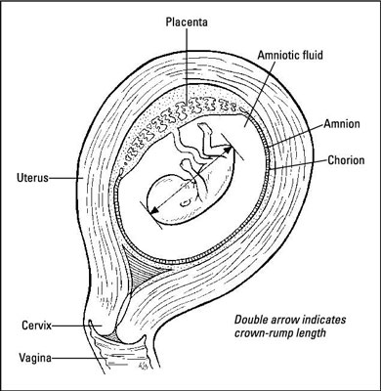

**ii.**

**iii.**

**iv.**

(a) What is the name of structure (i)? List 2 of its functions (3 marks)

**Placenta (1)**

**Endocrine, excretory, immune, nutrition, respiration (1 mark for each mentioned)**

1. Structure (ii) can be used for genetic screening purposes. What is the name of this screening technique and give an example of what it would test for? (2 marks)

**Amniocentesis (1)**

**Any form of chromosomal mutation. i.e. down syndrome, Down syndrome, cystic fibrosis, neural tube defects, and genetic disorders such as DMD and sickle cell disease (1)**24. During pregnancy it is very important to avoid exposure to teratogens. Some examples of teratogens are chemicals such as thalidomide and mercury. Define teratogen and give two other examples of teratogens. (3 marks)

**Teratogen – any agent that causes defects in a developing embryo (1)**

**Examples – alcohol, listeriosis, smoking, etc. (2)**

25. Stem cells are used for research all around the world with limited implications and ethical issues. They can be sourced from 3 main places, name where they are sourced from, the type of stem cell they are (totipotent, pluripotent or multipotent) and then give one positive implication for their use. (9 marks)

|  |  |  |
| --- | --- | --- |
| **Source** | **Stem cell classification** | **Positive to using this type** |
| **Placenta and umbilical cord** | **Multipotent** | **Can be stored for baby  No rejection  No harm** |
| **Embryonic** | **Pluripotent** | **Uses frozen/unused embryos  from IVF can be used to treat all body  cell issues** |
| **Adult** | **Multipotent** | **No rejection** |

**1 mark for each category**

26. Infertility refers to the biological inability of a person or couple to conceive under natural conditions. Some types of infertility can be overcome with in-vitro fertilization (IVF). Explain the procedure used in IVF. (5 marks)

**Sperm and egg are mixed together in a test tube (1)  
Fertilisation occurs (1)  
Embryo is allowed to grow to the blastocyst stage (1)  
(Day 5) (1)  
It is then transferred to the woman to be implanted in the uterus (1)**

**PART C: EXTENDED ANSWER SECTION (15 Marks)**

The process of birth or parturition involves 3 separate stages. In the space provided below:

* Name the different stages
* Explain when they begin/end
* How long they last for
* Steps involved in each stage

**Dialation stage (1)**

**Begins with contractions being 30 minutes apart (1/2) ends with full dilation (1/2)**

**Lasts anywhere between 8-9 hours first child, 4 hours every child after that (1)**

**Contractions start from the top of the uterus and wave down to the cervix (1)**

**contraction results in the uterine muscle shortening = pulls on the cervix to open it (1)**

**Expulsion stage (1)**

**Begins with the bursting of the amniotic membrane (1/2) ends with baby exiting mother (1/2)**

**Lasts between 20 mins – 2 hours (1)**

**Crowning occurs (1), mother pushes, babies head faces down to mothers back, babies head then turns left to hip, shoulders and remaining body exits (1)**

**After birth (1)**

**Begins with baby being delivered (1/2) ends with delivery of placenta, amnion and chorion (1/2)**

**Lasts around 5 minutes (1)**

**Cord is clamped, tied in 2 places and then and cut between the ties (1)**

**Blood clots form on the mother’s endometrium to prevent blood loss and infection (1)**

**END OF TEST**